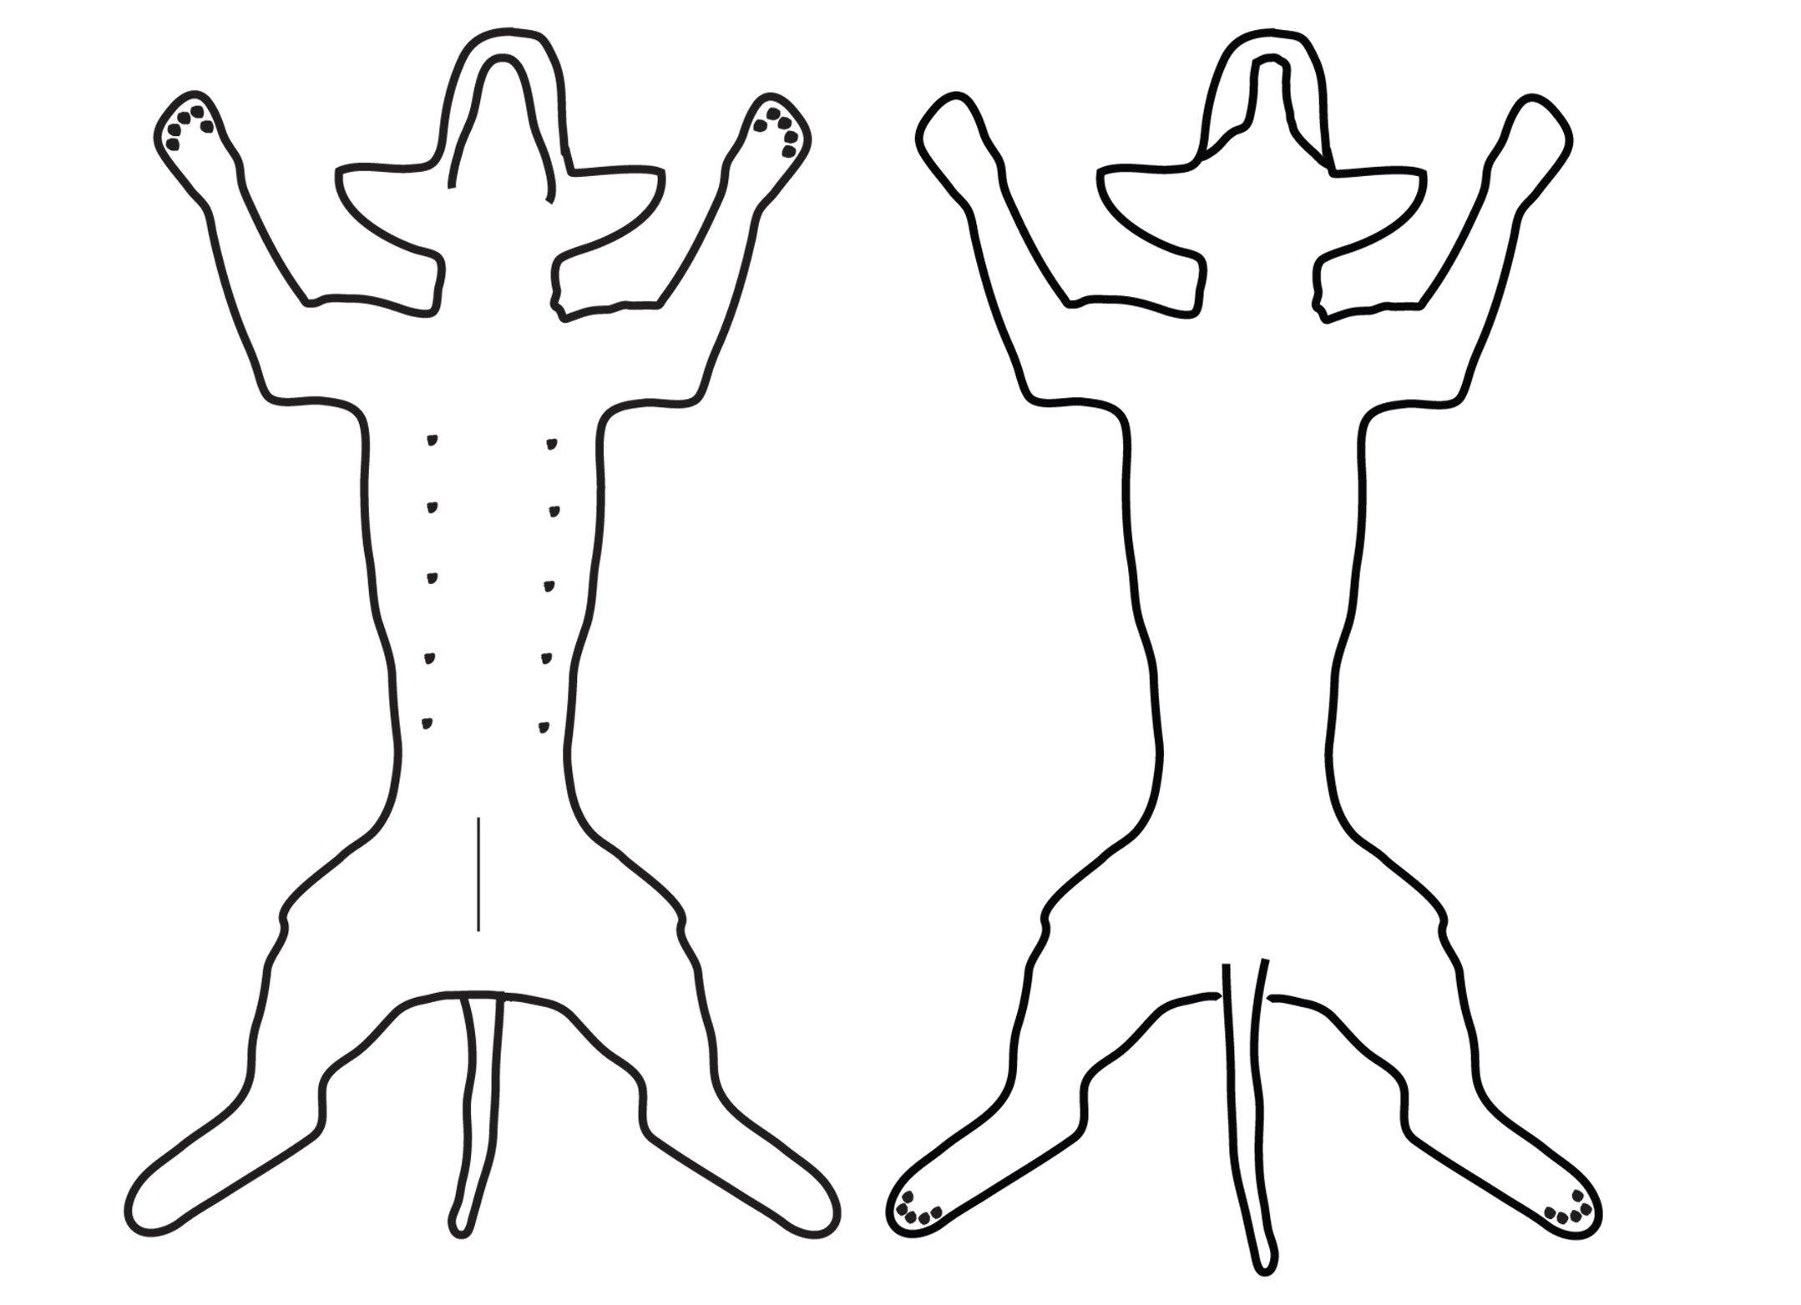
Dog Body Map

Ventral (belly) Dorsal (back)

Legend:

Heat Cold Tension Weakness Twitching Pain

Notes:

